var lbhValue = getBeamValue('lbh')

var bmh = getBeamValue('bmh')

var abc = getBeamValue('abc')

var asd = getBeamValue('bla bla bla bla')

function getBeamValue(beamType) {

var result

var beam = document.getElementById(beamType);

result = parseFloat(beam.value)

return result

}

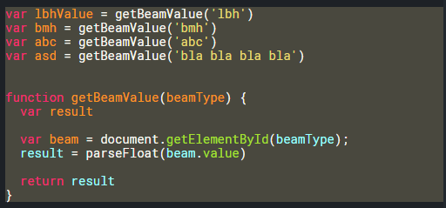

var lbhValue = getBeamValue('lbh')

var bmh = getBeamValue('bmh')

var abc = getBeamValue('abc')

var asd = getBeamValue('bla bla bla bla')

function getBeamValue(beamType) {

var result

var beam = document.getElementById(beamType);

result = parseFloat(beam.value)

return result

}

function getBeamValue(beamType) {

var beam = document.getElementById(beamType);

return parseFloat(beam.value)

}

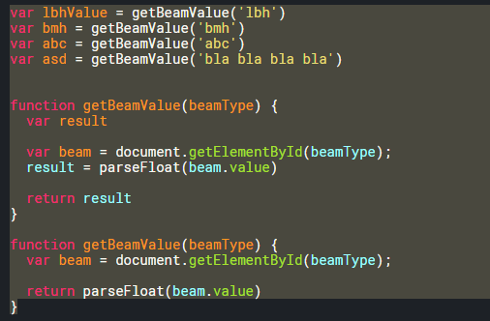

var lbhValue = getBeamValue('lbh')

var bmhValue = getBeamValue('bmh')

var abcValue = getBeamValue('abc')

var asdValue = getBeamValue('asd')

var calculateButton = document.getElementById('calculateButton')

calculateButton.addEventListener('click', function() {

var results = getResult()

showResultsToUser(results)

})

// helper functions

function getResult() {

if (lbhValue > 0) {

return (lbhValue \* 15) / 100

}

else if (abc == 0) {

return (abcValue \* 10) / 100

}

}

function showResultsToUser (results) {

var resultSelector = document.getElementById('wynik')

resultSelector.innerHTML = results

}

function getBeamValue(beamType) {

var beam = document.getElementById(beamType);

return parseFloat(beam.value)

}

